# **ECEN 215 – PRIN OF ELECTRICAL ENGR**

# **Spring 2019**

## **Lab 4: First Order RC and RL Transients**



**Submitted by:**

|  |  |  |
| --- | --- | --- |
| **Student Name** | **UIN:** | **Section #** |
| Daniel Lopez | 426001591 | 516 |
| Adam Johnston | 516007336 |
| Jared Blunt | 524009660 |  |

**Date Performed: March 4th, 2019**

1. **Objective**

The objective of this lab is to calculate the time constants for basic RC and RL circuits, using the given, initial information about each. These circuits are then duplicated in real life, and instead of ideal values; tested, real-life figures are used to, along with Waveform Software, to find the time constant. These two data sets are then compared to one another.

1. **Procedure**

**RC Circuit**

1. The following steps are repeated three times for the RC circuit; with 1uF, 10uF, 100uF
2. Calculate the time constant, τtheoretical , using the given information for the circuit
3. On the breadboard, using resistors, capacitors and wires, as needed, build the given circuit
4. Using the multimeter, measure and record the following values:

* The resistance for all the components in the circuit
* Actual, Vs , being supplied to the circuit
* Capacitance of the given capacitor

1. Use waveform to measure the change in voltage over time, and to find the time constant, τactual

**RL Circuit**

1. Calculate the time constant, τtheoretical , using the given information for the circuit
2. Build On the breadboard, using resistors, inductors, and wires, as needed, build the given circuit
3. Use the multimeter to measure and record the following values:

* Resistance of all the components in the circuit
* Voltage actual, Vs , being supplied to the circuit

1. Use waveform to measure the change in voltage over time, and to find the time constant, τactual
2. **Difficulties**
3. Damaged components
4. Components with different values than what was needed for the lab
5. Being unable to measure individuals inductors
6. Difficulty keeping wires inside the Analog Discovery
7. Issues with the Waveform software giving incorrect data
8. Interpolating data from the Waveform software
9. **Results**

**Components (RC Circuits)**

|  |  |  |
| --- | --- | --- |
| **Component** | **Theoretical Value** | **Measured Value** |
| **R** | 1 kOhm | 0.986 kOhm |
| **Vsupply  (20 Hz Square Wave)** | 1 V | 0.996 V |
| **C1** | 1 uF | 1.1 uF |
| **C2** | 10 uF | 9.3 uF |
| **C3** | 100 uF | 98.4 uF |

**Components (RL Circuit)**

|  |  |  |
| --- | --- | --- |
| **Component** | **Theoretical Value** | **Measured Value** |
| **R1** | 220 Ohm | 216.6 Ohm |
| **R2** | 100 Ohm | 98 Ohm |
| **R3** | 100 Ohm | 99.6 Ohm |
| **R4** | 1000 Ohm | 986 Ohm |
| **Leq** | 360 mH (3 x 120 mH) | N / A |
| **Vsupply  (20 Hz Square Wave)** | 1 V | 0.996 V |

**Time Constants (RC Circuits)**

|  |  |  |  |
| --- | --- | --- | --- |
|  | **Calculated Value** | **Measured Value** | **Error** |
| **RC1** | 1.084 uS | 1.184 uS | 9.22 % |
| **RC2** | 9.169 uS | N/A | N/A |
| **RC3** | 97.02 uS | N/A | N/A |

**Time Constants (RL Circuits)**

|  |  |  |  |
| --- | --- | --- | --- |
|  | **Calculated Value** | **Measured Value** | **Error** |
| **RL = R1 + R2 + R3 + R4** | 1400 Ohm | N/A | N/A |
| **Leq / RL** | 257.1 uS | 215.9 uS | 16.0 % |

**Oscilloscope Screenshots:**

Capacitor = 1 uF

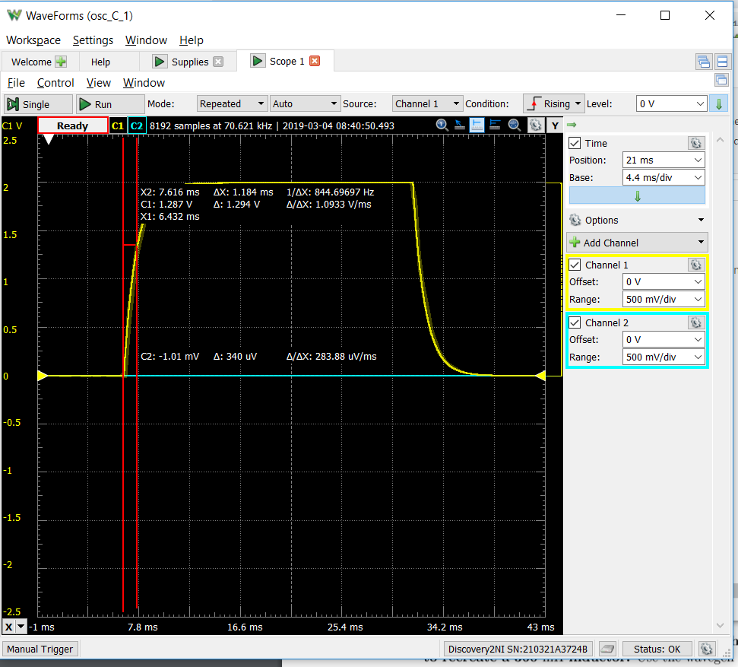

Capacitor = 10 uF

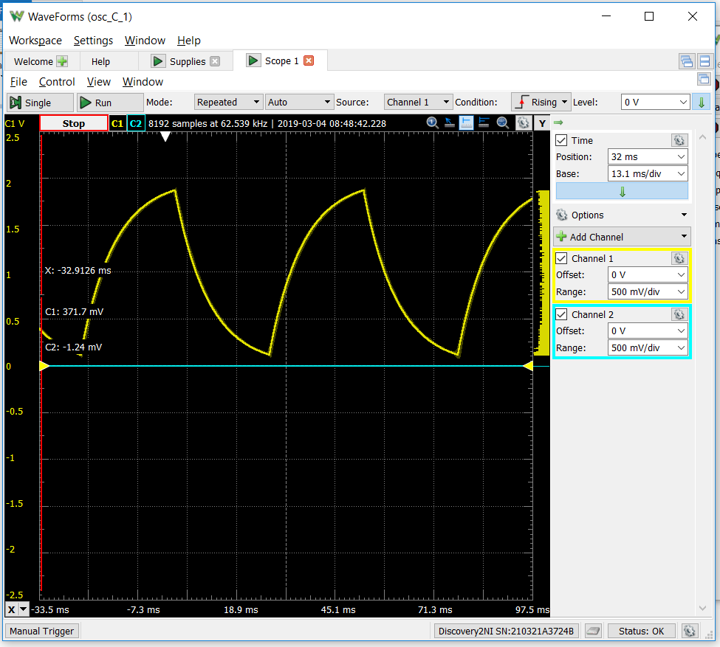

Capacitor = 100 uF

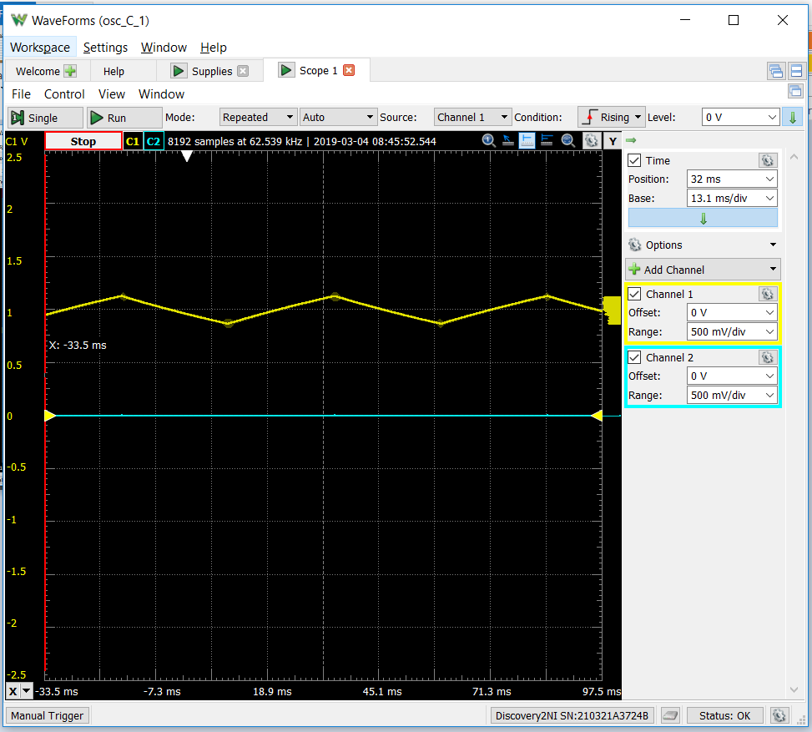

Inductor Circuit

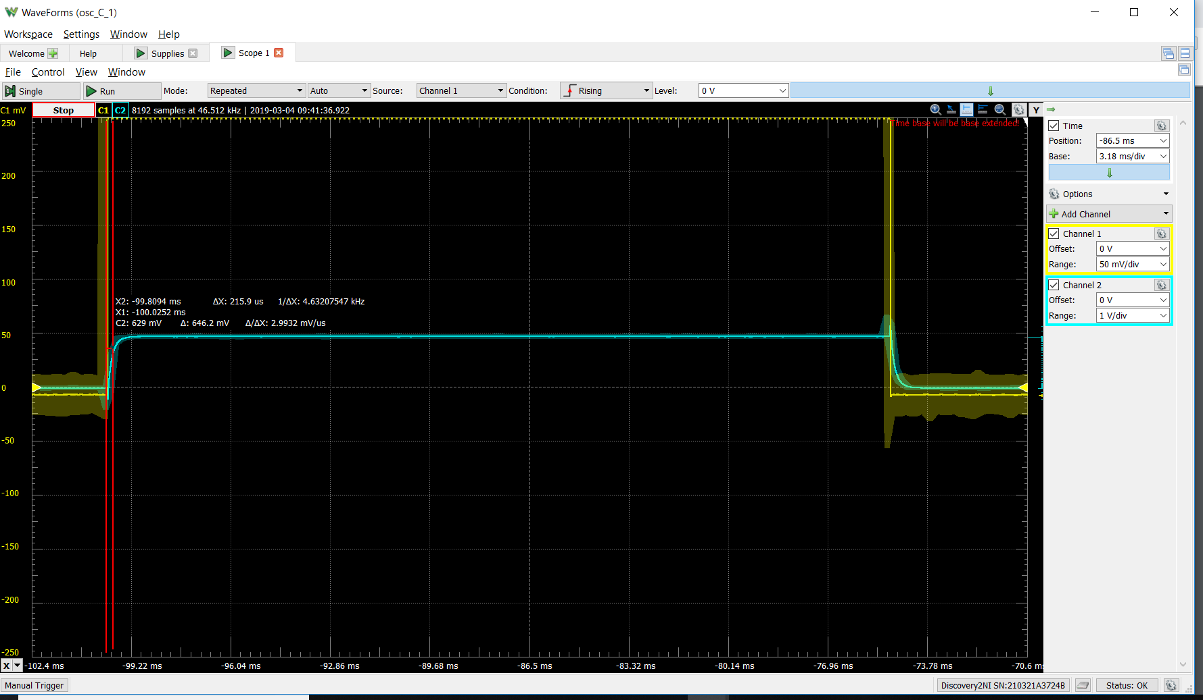

1. **Conclusion**

From the oscilloscope readings we can see that a small capacitance in an RC circuit, which leads to a smaller time constant, results in a steep curve and reaches maximum voltage very quickly. As the capacitance is increased, we start to see triangular waveforms because the larger time constant results in the capacitor not being able to reach maximum voltage within a single cycle of the square wave voltage source. The inductor circuit showed similar behavior to the 1 uF capacitor circuit. Our largest error was the inductor circuit, which is most likely because we had no way of measuring the actual inductance of each component, so we had to use the rated value in our calculations. Because we used three inductors in series to create the 360 mH inductance, the difference between the actual inductance and rated inductance for each component would have an effect on the outcome.